**MLA0413-Deep Learning for Complex Data Mining**

**NAME: N. Pavan Sai**

**REG NO: 192225023**

**EXPERIMENT:1(A)**

**AIM:** To demonstrate confusion matrix using python

**PROGRAM:** #Import the necessary libraries

import numpy as np

from sklearn.metrics import confusion_matrix

import seaborn as sns

import matplotlib.pyplot as plt

#Create the NumPy array for actual and predicted labels.

actual    = np.array(

  ['Dog','Dog','Dog','Not Dog','Dog','Not Dog','Dog','Dog','Not Dog','Not Dog'])

predicted = np.array(

  ['Dog','Not Dog','Dog','Not Dog','Dog','Dog','Dog','Dog','Not Dog','Not Dog'])

#compute the confusion matrix.

cm = confusion_matrix(actual,predicted)

#Plot the confusion matrix.

sns.heatmap(cm,

            annot=True,

            fmt='g',

            xticklabels=['Dog','Not Dog'],

            yticklabels=['Dog','Not Dog'])

plt.ylabel('Prediction',fontsize=13)

plt.xlabel('Actual',fontsize=13)

plt.title('Confusion Matrix',fontsize=17)

plt.show()

**OUTPUT:**

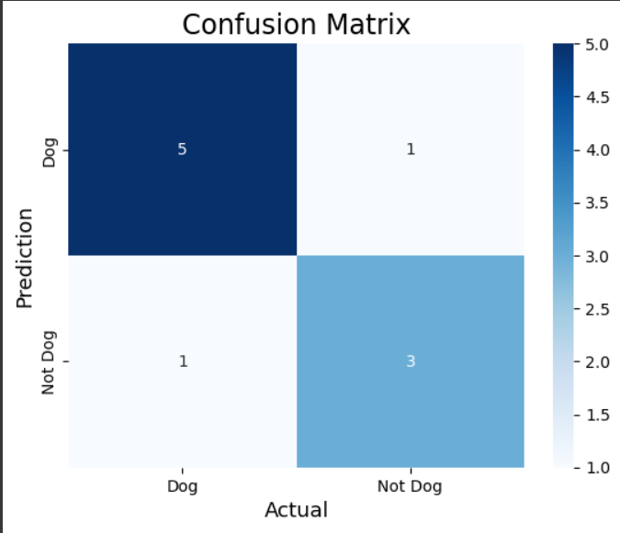

**EXPERIMENT:1(B)**

**AIM:** To demonstrate 2 class confusion matrix using python

**PROGRAM:**

#Import the necessary libraries

from sklearn.datasets import load_breast_cancer

from sklearn.model_selection import train_test_split

from sklearn.tree import DecisionTreeClassifier

from sklearn.metrics import confusion_matrix

import seaborn as sns

import matplotlib.pyplot as plt

from sklearn.metrics import accuracy_score, precision_score, recall_score, f1_score

# Load the breast cancer dataset

X, y= load_breast_cancer(return_X_y=True)

X_train, X_test, y_train, y_test = train_test_split(X, y,test_size=0.25)

# Train the model

tree = DecisionTreeClassifier(random_state=23)

tree.fit(X_train, y_train)

# preduction

y_pred = tree.predict(X_test)

# compute the confusion matrix

cm = confusion_matrix(y_test,y_pred)

#Plot the confusion matrix.

sns.heatmap(cm,

            annot=True,

            fmt='g',

            xticklabels=['malignant', 'benign'],

            yticklabels=['malignant', 'benign'])

plt.ylabel('Prediction',fontsize=13)

plt.xlabel('Actual',fontsize=13)

plt.title('Confusion Matrix',fontsize=17)

plt.show()

# Finding precision and recall

accuracy = accuracy_score(y_test, y_pred)

print("Accuracy   :", accuracy)

precision = precision_score(y_test, y_pred)

print("Precision :", precision)

recall = recall_score(y_test, y_pred)

print("Recall    :", recall)

F1_score = f1_score(y_test, y_pred)

print("F1-score  :", F1_score)

**OUTPUT:**

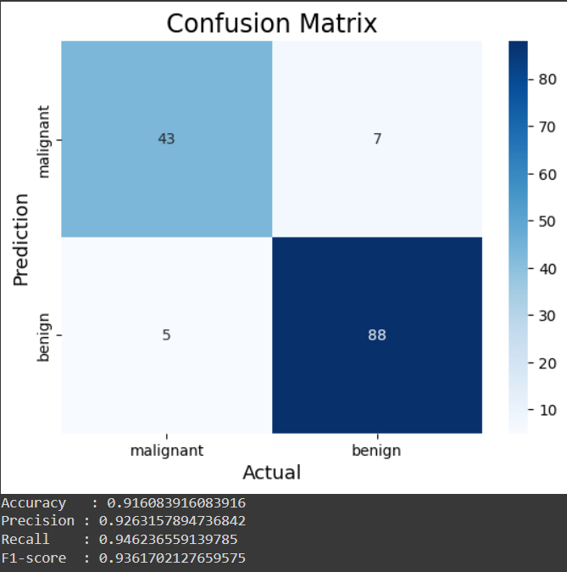

**EXPERIMENT:2**

**AIM:** Verifying the performance of a multi class confusion matrix by using choosen database with phython code

**PROGRAM:**

#Import the necessary libraries

from sklearn.datasets import load_digits

from sklearn.model_selection import train_test_split

from sklearn.ensemble import RandomForestClassifier

from sklearn.metrics import confusion_matrix

import seaborn as sns

import matplotlib.pyplot as plt

from sklearn.metrics import accuracy_score, precision_score, recall_score, f1_score

# Load the breast cancer dataset

X, y= load_digits(return_X_y=True)

X_train, X_test, y_train, y_test = train_test_split(X, y,test_size=0.25)

# Train the model

clf = RandomForestClassifier(random_state=23)

clf.fit(X_train, y_train)

# preduction

y_pred = clf.predict(X_test)

# compute the confusion matrix

cm = confusion_matrix(y_test,y_pred)

#Plot the confusion matrix.

sns.heatmap(cm,

            annot=True,

            fmt='g')

plt.ylabel('Prediction',fontsize=13)

plt.xlabel('Actual',fontsize=13)

plt.title('Confusion Matrix',fontsize=17)

plt.show()

# Finding precision and recall

accuracy = accuracy_score(y_test, y_pred)

print("Accuracy   :", accuracy)

**OUTPUT:**

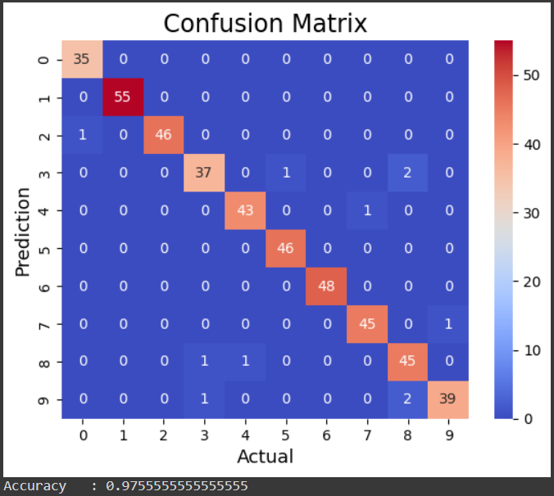

**EXPERIMENT:3**

**AIM:** : Verifying the performance of a over fitting by using choosen database with python code

**PROGRAM:**

import numpy as np

import matplotlib.pyplot as plt

from sklearn.pipeline import Pipeline

from sklearn.preprocessing import PolynomialFeatures

from sklearn.linear_model import LinearRegression

from sklearn.model_selection import cross_val_score

def true_fun(X):

    return np.cos(1.5 * np.pi * X)

np.random.seed(0)

n_samples = 30

degrees = [1, 4, 15]

X = np.sort(np.random.rand(n_samples))

y = true_fun(X) + np.random.randn(n_samples) * 0.1

plt.figure(figsize=(14, 5))

for i in range(len(degrees)):

    ax = plt.subplot(1, len(degrees), i + 1)

    plt.setp(ax, xticks=(), yticks=())

    polynomial_features = PolynomialFeatures(degree=degrees[i], include_bias=False)

    linear_regression = LinearRegression()

    pipeline = Pipeline(

        [

            ("polynomial_features", polynomial_features),

            ("linear_regression", linear_regression),

        ]

    )

    pipeline.fit(X[:, np.newaxis], y)

    # Evaluate the models using crossvalidation

    scores = cross_val_score(

        pipeline, X[:, np.newaxis], y, scoring="neg_mean_squared_error", cv=10

    )

    X_test = np.linspace(0, 1, 100)

    plt.plot(X_test, pipeline.predict(X_test[:, np.newaxis]), label="Model")

    plt.plot(X_test, true_fun(X_test), label="True function")

    plt.scatter(X, y, edgecolor="b", s=20, label="Samples")

    plt.xlabel("x")

    plt.ylabel("y")

    plt.xlim((0, 1))

    plt.ylim((-2, 2))

    plt.legend(loc="best")

    plt.title(

        "Degree {}\nMSE = {:.2e}(+/- {:.2e})".format(

            degrees[i], -scores.mean(), scores.std()

        )

    )

plt.show()

**OUTPUT:**

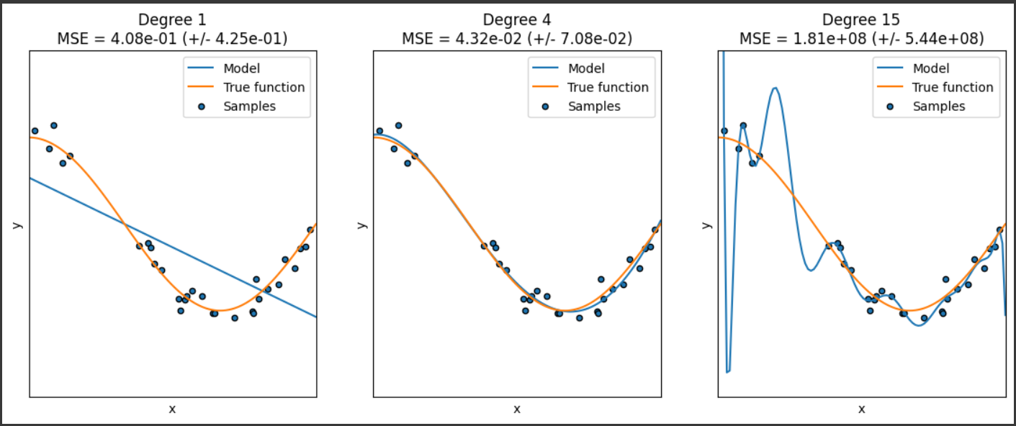

**EXPERIMENT:4**

**AIM:** To demonstrate the performance of a linear regression by using choosen database with python code

**PROGRAM: LINEAR REGRESSION**

import numpy as np

import matplotlib.pyplot as plt

def estimate_coef(x, y):

    # number of observations/points

    n = np.size(x)

    # mean of x and y vector

    m_x = np.mean(x)

    m_y = np.mean(y)

    # calculating cross-deviation and deviation about x

    SS_xy = np.sum(y*x) - n*m_y*m_x

    SS_xx = np.sum(x*x) - n*m_x*m_x

    # calculating regression coefficients

    b_1 = SS_xy / SS_xx

    b_0 = m_y - b_1*m_x

    return (b_0, b_1)

def plot_regression_line(x, y, b):

    # plotting the actual points as scatter plot

    plt.scatter(x, y, color = "r",

               marker = "o", s = 30)

    # predicted response vector

    y_pred = b[0] + b[1]*x

    # plotting the regression line

    plt.plot(x, y_pred, color = "b")

    # putting labels

    plt.xlabel('x')

    plt.ylabel('y')

    # function to show plot

    plt.show()

def main():

    # observations / data

    x = np.array([0, 1, 2, 3, 4, 5, 6, 7, 8, 9])

    y = np.array([1, 3, 2, 5, 7, 8, 8, 9, 10, 12])

    # estimating coefficients

    b = estimate_coef(x, y)

    print("Estimated coefficients:\nb_0 = {}  \

          \nb_1 = {}".format(b[0], b[1]))

    # plotting regression line

    plot_regression_line(x, y, b)

if __name__ == "__main__":

    main()

**OUTPUT:**

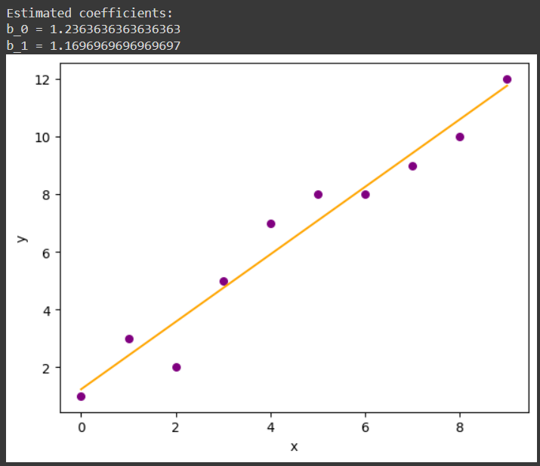

**EXPERIMENT:5**

**AIM:** : To demonstrate the performance of a logistic regression by using choosen database with python code.

**PROGRAM:**

import numpy as np

import matplotlib.pyplot as plt

def sigmoid(z):

    return 1 / (1 + np.exp( - z))

plt.plot(np.arange(-5, 5, 0.1), sigmoid(np.arange(-5, 5, 0.1)))

plt.title('Visualization of the Sigmoid Function')

plt.show()

**OUTPUT:**

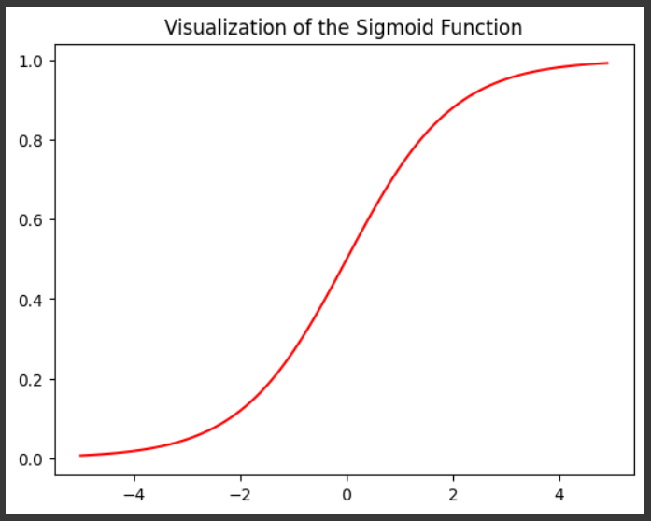

**EXPERIMENT:6(a)KNN**

**AIM:** Finding accuracy value of iris data set using KNN algorithm

**PROGRAM:**

import numpy as np

import pandas as pd

dataset = pd.read_csv("/content/IRIS.csv")

"""

The breast cancer dataset has the following features: Sample code number, Clump Thickness, Uniformity of Cell Size,

Uniformity of Cell Shape, Marginal Adhesion, Single Epithelial Cell Size, Bare Nuclei, Bland Chromatin,

Normal Nucleoli, Mitosis, Class.

"""

X = dataset.iloc[:, :-1].values

y = dataset.iloc[:, -1].values

dataset.shape

#splitting the dataset into the Training set and Test set

from sklearn.model_selection import train_test_split

X_train, X_test, y_train, y_test = train_test_split(X, y, test_size = 0.20, random_state = 42)

#Feature Scaling

"""

Feature scaling is the process of converting the data into a given range.

In this case, the standard scalar technique is used.

"""

from sklearn.preprocessing import StandardScaler

sc = StandardScaler()

X_train = sc.fit_transform(X_train)

X_test = sc.transform(X_test)

#Training the K-Nearest Neighbors (K-NN) Classification model on the Training set

"""

Once the dataset is scaled, next, the K-Nearest Neighbors (K-NN) classifier algorithm is used to create a model.

The hyperparameters such as n_neighbors, metric, and p are set to 5, Minkowski, and 2 respectively.

The remaining hyperparameters are set to default values.

"""

from sklearn.neighbors import KNeighborsClassifier

classifier = KNeighborsClassifier(n_neighbors = 5, metric = 'minkowski', p = 2)

classifier.fit(X_train, y_train)

"""

Display the results (confusion matrix and accuracy)

Here evaluation metrics such as confusion matrix and accuracy are used to evaluate the performance of the model built using a decision tree classifier.

"""

from sklearn.metrics import confusion_matrix, accuracy_score

y_pred = classifier.predict(X_test)

cm = confusion_matrix(y_test, y_pred)

print(cm)

accuracy_score(y_test, y_pred)

**OUTPUT:**

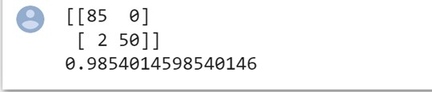

**EXPERIMENT:6(B)NAVIE**

**AIM: :** finding accuracy value of iris data set using NAVIE BAYES algorithm

**PROGRAM:**

import numpy as np

import pandas as pd

#Importing the dataset

"""

Next, we import or read the dataset. Click here to download the breast cancer dataset used in this implementation.

After reading the dataset, divide the dataset into concepts and targets. Store the concepts into X and

targets into y.

"""

dataset = pd.read_csv("/content/IRIS.csv ")

X = dataset.iloc[:, :-1].values

y = dataset.iloc[:, -1].values

"""

Splitting the dataset into the Training set and Test set

Once the dataset is read into the memory, next, divide the dataset into two parts, training and

testing using the train_test_split function from sklearn.

The test_size and random_state attributes are set to 0.25 and 0 respectively.

You can change these attributes as per your requirements.

"""

from sklearn.model_selection import train_test_split

X_train, X_test, y_train, y_test = train_test_split(X, y, test_size = 0.25, random_state = 0)

#Feature Scaling

"""

Feature scaling is the process of converting the data into a min-max range. In this case,

the standard scalar method is used.

"""

from sklearn.preprocessing import StandardScaler

sc = StandardScaler()

X_train = sc.fit_transform(X_train)

X_test = sc.transform(X_test)

"""

Training the Naive Bayes Classification model on the Training set

Once the dataset is scaled, next, the Naive Bayes classifier algorithm is used to create a model.

The GaussianNB function is imported from sklearn.naive_bayes library. The hyperparameters such as kernel,

and random_state to linear, and 0 respectively. The remaining hyperparameters of the support vector machine

algorithm are set to default values.

"""

from sklearn.naive_bayes import GaussianNB

classifier = GaussianNB()

classifier.fit(X_train, y_train)

#Naive Bayes classifier model

GaussianNB(priors=None, var_smoothing=1e-09)

#Display the results (confusion matrix and accuracy)

"""

Here evaluation metrics such as confusion matrix and accuracy are used to evaluate the performance of

the model built using a decision tree classifier.

"""

from sklearn.metrics import confusion_matrix, accuracy_score

y_pred = classifier.predict(X_test)

cm = confusion_matrix(y_test, y_pred)

print(cm)

accuracy_score(y_test, y_pred)

**OUTPUT:**

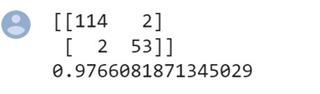

**EXPERIMENT:6(C)LOGISTIC**

**AIM: :** finding accuracy value of iris data set using LOGISTIC REGRESSION algorithm

**PROGRAM:**

import numpy as np

import pandas as pd

#"Importing the dataset

"""

After importing the necessary libraries, next, we import or read the dataset.

Click here to download the breast cancer dataset used in this implementation.

The breast cancer dataset has the following features:

Sample code number, Clump Thickness, Uniformity of Cell Size, Uniformity of Cell Shape, Marginal Adhesion,

Single Epithelial Cell Size, Bare Nuclei, Bland Chromatin, Normal Nucleoli, Mitosis, Class.

"""

# divide the dataset into concepts and targets. Store the concepts into X and targets into y.

dataset = pd.read_csv("/content/IRIS.csv ")

X = dataset.iloc[:, :-1].values

y = dataset.iloc[:, -1].values

#Splitting the dataset into the Training set and Test

from sklearn.model_selection import train_test_split

X_train, X_test, y_train, y_test = train_test_split(X, y, test_size = 0.30, random_state = 2)

#Feature Scaling

"""

Feature scaling is the process of converting the data into a given range. In this case, the standard scalar technique is used.

from sklearn.preprocessing import StandardScaler

"""

from sklearn.preprocessing import StandardScaler

sc = StandardScaler()

X_train = sc.fit_transform(X_train)

X_test = sc.transform(X_test)

"""

Training the Logistic Regression (LR) Classification model on the Training set

Once the dataset is scaled, next, the Logistic Regression (LR) classifier algorithm is used to create a model.

The hyperparameters such as random_state to 0 respectively.

The remaining hyperparameters Logistic Regression (LR) are set to default values.

"""

from sklearn.linear_model import LogisticRegression

classifier = LogisticRegression(random_state = 0)

classifier.fit(X_train, y_train)

#Logistic Regression (LR) classifier model

LogisticRegression(C=1.0, class_weight=None, dual=False, fit_intercept=True,

intercept_scaling=1, l1_ratio=None, max_iter=100,

multi_class='warn', n_jobs=None, penalty='l2',

random_state=0, solver='warn', tol=0.0001, verbose=0,

warm_start=False)

#Display the results (confusion matrix and accuracy)

"""

Here evaluation metrics such as confusion matrix and accuracy are used to evaluate the performance of the model

built using a decision tree classifier.

"""

from sklearn.metrics import confusion_matrix, accuracy_score

y_pred = classifier.predict(X_test)

cm = confusion_matrix(y_test, y_pred)

print(cm)

accuracy_score(y_test, y_pred)

**OUTPUT:**

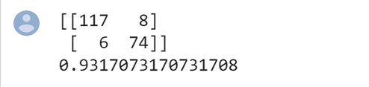

**EXPERIMENT:6(D)DECISION**

**AIM: :** finding accuracy value of iris data set using DECISION TREE algorithm

**PROGRAM:**

import numpy as np

import pandas as pd

# Importing the dataset

dataset = pd.read_csv("/content/IRIS.csv ")

X = dataset.iloc[:, :-1].values

y = dataset.iloc[:, -1].values

# Splitting the dataset into the Training set and Test set

from sklearn.model_selection import train_test_split

X_train, X_test, y_train, y_test = train_test_split(X, y, test_size = 0.25, random_state = 8)

# Feature Scaling

from sklearn.preprocessing import StandardScaler

sc = StandardScaler()

X_train = sc.fit_transform(X_train)

X_test = sc.transform(X_test)

# Training the Decision Tree Classification model on the Training set

from sklearn.tree import DecisionTreeClassifier

classifier = DecisionTreeClassifier(criterion = 'entropy', random_state = 5)

classifier.fit(X_train, y_train)

# Display the Decision Tree

from sklearn.tree import plot_tree

import matplotlib.pyplot as plt

plt.figure(figsize=(20,10))

plot_tree(classifier, filled=True, rounded=True, feature_names=dataset.columns[:-1])

plt.show()

# Predicting the Test set results

y_pred = classifier.predict(X_test)

# Display the results (confusion matrix and accuracy)

from sklearn.metrics import confusion_matrix, accuracy_score

cm = confusion_matrix(y_test, y_pred)

print(cm)

accuracy_score(y_test, y_pred)

**output:**

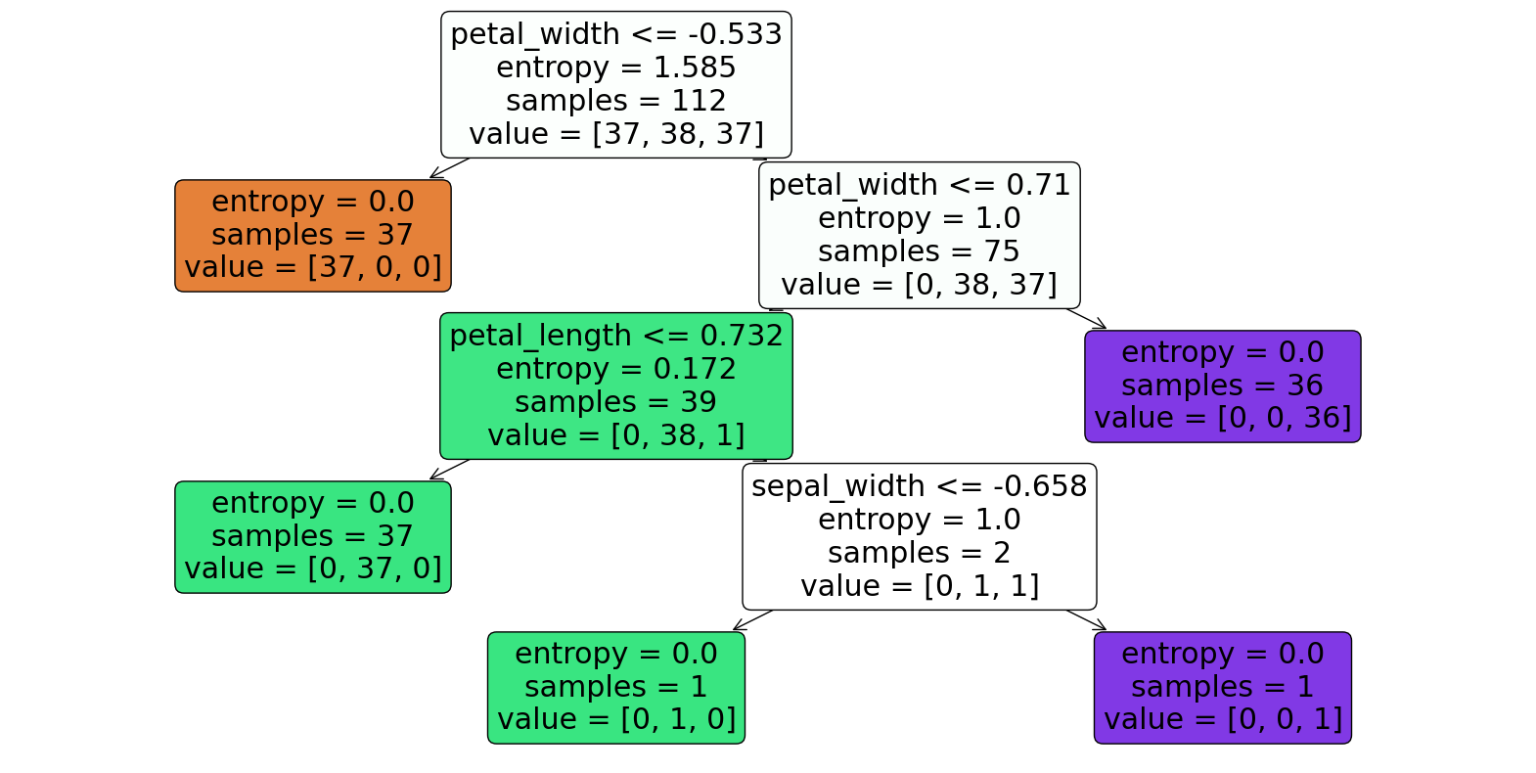

0.8947368421052632

[[13 0 0]

[ 0 11 1]

[ 0 3 10]]

**EXPERIMENT:6(E)SVM**

**AIM: :** finding accuracy value of iris data set using SVM algorithm

**PROGRAM:**

import numpy as np

import pandas as pd

# Importing the dataset

dataset = pd.read_csv("/content/IRIS.csv ")

X = dataset.iloc[:, :-1].values

y = dataset.iloc[:, -1].values

# Splitting the dataset into the Training set and Test set

from sklearn.model_selection import train_test_split

X_train, X_test, y_train, y_test = train_test_split(X, y, test_size=0.25, random_state=32)

# Feature Scaling

from sklearn.preprocessing import StandardScaler

sc = StandardScaler()

X_train = sc.fit_transform(X_train)

X_test = sc.transform(X_test)

# Training the SVM model on the Training set

from sklearn.svm import SVC

classifier = SVC(kernel='linear', random_state=0)

classifier.fit(X_train, y_train)

# Predicting the Test set results

y_pred = classifier.predict(X_test)

# Evaluating the performance of the model using confusion matrix and accuracy

from sklearn.metrics import confusion_matrix, accuracy_score

cm = confusion_matrix(y_test, y_pred)

print(cm)

print('Accuracy: {:.2f}%'.format(accuracy_score(y_test, y_pred) * 100))

**OUTPUT:**

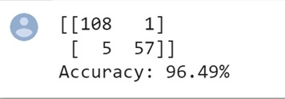

**EXPERIMENT:6(F)RANDOM**

**AIM: :** finding accuracy value of iris data set using RANDOM FOREST algorithm

**PROGRAM:**

import numpy as np

import pandas as pd

# Importing the dataset

dataset = pd.read_csv("/content/IRIS.csv ")

X = dataset.iloc[:, :-1].values

y = dataset.iloc[:, -1].values

# Splitting the dataset into the Training set and Test set

from sklearn.model_selection import train_test_split

X_train, X_test, y_train, y_test = train_test_split(X, y, test_size=0.25, random_state=39)

# Feature Scaling

from sklearn.preprocessing import StandardScaler

sc = StandardScaler()

X_train = sc.fit_transform(X_train)

X_test = sc.transform(X_test)

# Training the Random Forest Classification model on the Training set

from sklearn.ensemble import RandomForestClassifier

classifier = RandomForestClassifier(n_estimators=100, random_state=42)

classifier.fit(X_train, y_train)

# Predicting the Test set results

y_pred = classifier.predict(X_test)

# Making the Confusion Matrix

from sklearn.metrics import confusion_matrix, accuracy_score

cm = confusion_matrix(y_test, y_pred)

print(cm)

print('Accuracy:', accuracy_score(y_test, y_pred))

**OUTPUT:**

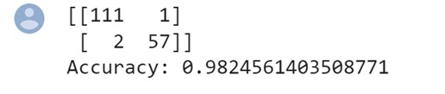

**EXPERIMENT:7(A)**

**AIM:** To demonstrate gradient descent using python(actual data)

**PROGRAM:**

# Importing Libraries

import numpy as np

import matplotlib.pyplot as plt

def mean_squared_error(y_true, y_predicted):

    # Calculating the loss or cost

    cost = np.sum((y_true-y_predicted)**2) / len(y_true)

    return cost

# Gradient Descent Function

# Here iterations, learning_rate, stopping_threshold

# are hyperparameters that can be tuned

def gradient_descent(x, y, iterations = 1000, learning_rate = 0.0001,

                     stopping_threshold = 1e-6):

    # Initializing weight, bias, learning rate and iterations

    current_weight = 0.1

    current_bias = 0.01

    iterations = iterations

    learning_rate = learning_rate

    n = float(len(x))

    costs = []

    weights = []

    previous_cost = None

    # Estimation of optimal parameters

    for i in range(iterations):

        # Making predictions

        y_predicted = (current_weight * x) + current_bias

        # Calculating the current cost

        current_cost = mean_squared_error(y, y_predicted)

        # If the change in cost is less than or equal to

        # stopping_threshold we stop the gradient descent

        if previous_cost and abs(previous_cost-current_cost)<=stopping_threshold:

            break

        previous_cost = current_cost

        costs.append(current_cost)

        weights.append(current_weight)

        # Calculating the gradients

        weight_derivative = -(2/n) * sum(x * (y-y_predicted))

        bias_derivative = -(2/n) * sum(y-y_predicted)

        # Updating weights and bias

        current_weight = current_weight - (learning_rate * weight_derivative)

        current_bias = current_bias - (learning_rate * bias_derivative)

        # Printing the parameters for each 1000th iteration

        print(f"Iteration {i+1}: Cost {current_cost}, Weight \

        {current_weight}, Bias {current_bias}")

    # Visualizing the weights and cost at for all iterations

    plt.figure(figsize = (8,6))

    plt.plot(weights, costs)

    plt.scatter(weights, costs, marker='o', color='red')

    plt.title("Cost vs Weights")

    plt.ylabel("Cost")

    plt.xlabel("Weight")

    plt.show()

    return current_weight, current_bias

def main():

    # Data

    X = np.array([32.50234527, 53.42680403, 61.53035803, 47.47563963, 59.81320787,

           55.14218841, 52.21179669, 39.29956669, 48.10504169, 52.55001444,

           45.41973014, 54.35163488, 44.1640495 , 58.16847072, 56.72720806,

           48.95588857, 44.68719623, 60.29732685, 45.61864377, 38.81681754])

    Y = np.array([31.70700585, 68.77759598, 62.5623823 , 71.54663223, 87.23092513,

           78.21151827, 79.64197305, 59.17148932, 75.3312423 , 71.30087989,

           55.16567715, 82.47884676, 62.00892325, 75.39287043, 81.43619216,

           60.72360244, 82.89250373, 97.37989686, 48.84715332, 56.87721319])

    # Estimating weight and bias using gradient descent

    estimated_weight, estimated_bias = gradient_descent(X, Y, iterations=2000)

    print(f"Estimated Weight: {estimated_weight}\nEstimated Bias: {estimated_bias}")

    # Making predictions using estimated parameters

    Y_pred = estimated_weight*X + estimated_bias

    # Plotting the regression line

    plt.figure(figsize = (8,6))

    plt.scatter(X, Y, marker='o', color='red')

    plt.plot([min(X), max(X)], [min(Y_pred), max(Y_pred)], color='blue',markerfacecolor='red',

             markersize=10,linestyle='dashed')

    plt.xlabel("X")

    plt.ylabel("Y")

    plt.show()

if __name__=="__main__":

    main()

**output:**

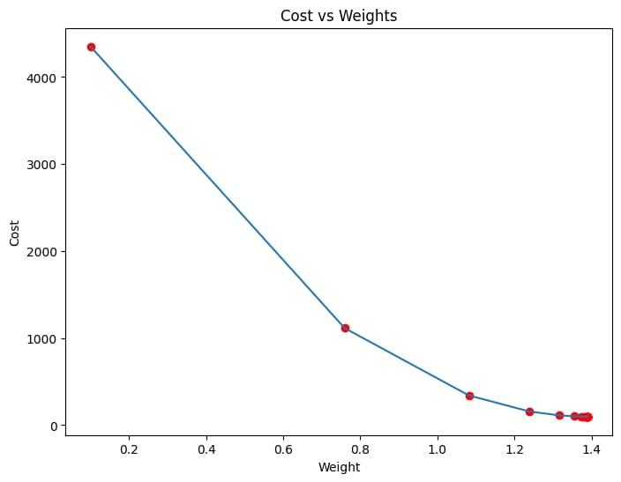

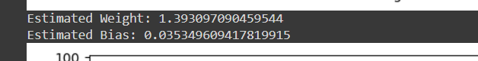

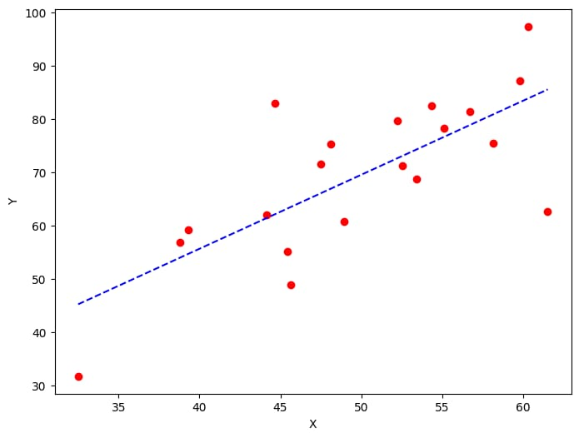

**Experiment:7(b)**

**AIM:** To demonstrate gradient descent using python( modified data)

**PROGRAM:**

# Importing Libraries

import numpy as np

import matplotlib.pyplot as plt

def mean_squared_error(y_true, y_predicted):

    # Calculating the loss or cost

    cost = np.sum((y_true-y_predicted)**2) / len(y_true)

    return cost

# Gradient Descent Function

# Here iterations, learning_rate, stopping_threshold

# are hyperparameters that can be tuned

def gradient_descent(x, y, iterations = 1000, learning_rate = 0.0001,

                     stopping_threshold = 1e-6):

    # Initializing weight, bias, learning rate and iterations

    current_weight = 0.1

    current_bias = 0.01

    iterations = iterations

    learning_rate = learning_rate

    n = float(len(x))

    costs = []

    weights = []

    previous_cost = None

    # Estimation of optimal parameters

    for i in range(iterations):

        # Making predictions

        y_predicted = (current_weight * x) + current_bias

        # Calculating the current cost

        current_cost = mean_squared_error(y, y_predicted)

        # If the change in cost is less than or equal to

        # stopping_threshold we stop the gradient descent

        if previous_cost and abs(previous_cost-current_cost)<=stopping_threshold:

            break

        previous_cost = current_cost

        costs.append(current_cost)

        weights.append(current_weight)

        # Calculating the gradients

        weight_derivative = -(2/n) * sum(x * (y-y_predicted))

        bias_derivative = -(2/n) * sum(y-y_predicted)

        # Updating weights and bias

        current_weight = current_weight - (learning_rate * weight_derivative)

        current_bias = current_bias - (learning_rate * bias_derivative)

        # Printing the parameters for each 1000th iteration

        print(f"Iteration {i+1}: Cost {current_cost}, Weight \

        {current_weight}, Bias {current_bias}")

    # Visualizing the weights and cost at for all iterations

    plt.figure(figsize = (8,6))

    plt.plot(weights, costs)

    plt.scatter(weights, costs, marker='o', color='red')

    plt.title("Cost vs Weights")

    plt.ylabel("Cost")

    plt.xlabel("Weight")

    plt.show()

    return current_weight, current_bias

def main():

    # Data

    X = np.array([52.50234527, 63.42680403, 81.53035803, 47.47563963, 89.81320787,

           55.14218841, 52.21179669, 39.29956669, 48.10504169, 52.55001444,

           45.41973014, 54.35163488, 44.1640495 , 58.16847072, 56.72720806,

           48.95588857, 44.68719623, 60.29732685, 45.61864377, 38.81681754])

    Y = np.array([41.70700585, 78.77759598, 82.5623823 , 91.54663223, 77.23092513,

           78.21151827, 79.64197305, 59.17148932, 75.3312423 , 71.30087989,

           55.16567715, 82.47884676, 62.00892325, 75.39287043, 81.43619216,

           60.72360244, 82.89250373, 97.37989686, 48.84715332, 56.87721319])

    # Estimating weight and bias using gradient descent

    estimated_weight, estimated_bias = gradient_descent(X, Y, iterations=2000)

    print(f"Estimated Weight: {estimated_weight}\nEstimated Bias: {estimated_bias}")

    # Making predictions using estimated parameters

    Y_pred = estimated_weight*X + estimated_bias

    # Plotting the regression line

    plt.figure(figsize = (8,6))

    plt.scatter(X, Y, marker='orange', color='pink')

    plt.plot([min(X), max(X)], [min(Y_pred), max(Y_pred)], color='blue',markerfacecolor='red',

             markersize=10,linestyle='dashed')

    plt.xlabel("X")

    plt.ylabel("Y")

    plt.show()

if __name__=="__main__":

    main()

**OUTPUT:**

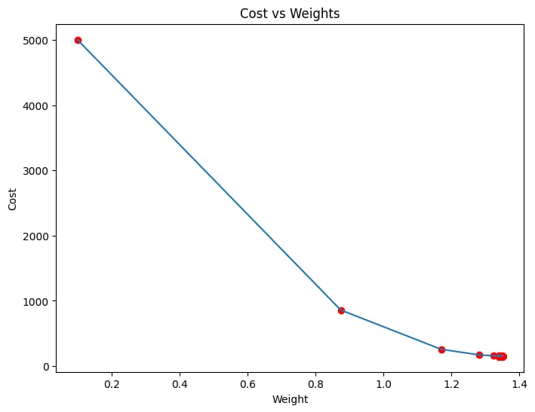



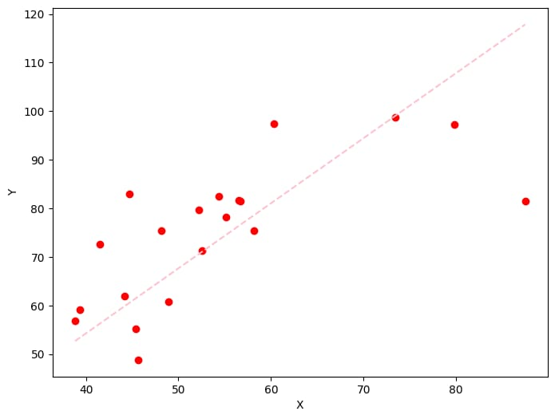

**EXPERIMENT:8(A)SEGMENTATION**

**AIM:** : Verifying the performance of a image processing by using choosen database with phython code

**PROGRAM:**

# SEGMENTATION

import numpy as np

import cv2

from matplotlib import pyplot as plt

img = cv2.imread(r'C33P1thinF_IMG_20150619_114756a_cell_181.png')

b,g,r = cv2.split(img)

rgb_img = cv2.merge([r,g,b])

gray = cv2.cvtColor(img,cv2.COLOR_BGR2GRAY)

ret, thresh = cv2.threshold(gray,0,255,cv2.THRESH_BINARY_INV+cv2.THRESH_OTSU)

# noise removal

kernel = np.ones((2,2),np.uint8)

#opening = cv2.morphologyEx(thresh,cv2.MORPH_OPEN,kernel, iterations = 2)

closing = cv2.morphologyEx(thresh,cv2.MORPH_CLOSE,kernel, iterations = 2)

# sure background area

sure_bg = cv2.dilate(closing,kernel,iterations=3)

# Finding sure foreground area

dist_transform = cv2.distanceTransform(sure_bg,cv2.DIST_L2,3)

# Threshold

ret, sure_fg = cv2.threshold(dist_transform,0.1*dist_transform.max(),255,0)

# Finding unknown region

sure_fg = np.uint8(sure_fg)

unknown = cv2.subtract(sure_bg,sure_fg)

# Marker labelling

ret, markers = cv2.connectedComponents(sure_fg)

# Add one to all labels so that sure background is not 0, but 1

markers = markers+1

# Now, mark the region of unknown with zero

markers[unknown==255] = 0

markers = cv2.watershed(img,markers)

img[markers == -1] = [255,0,0]

plt.subplot(211),plt.imshow(rgb_img)

plt.title('Input Image'), plt.xticks([]), plt.yticks([])

plt.subplot(212),plt.imshow(thresh, 'gray')

plt.imsave(r'thresh.png',thresh)

plt.title("Otsu's binary threshold"), plt.xticks([]), plt.yticks([])

plt.tight_layout()

plt.show()

**OUTPUT:**

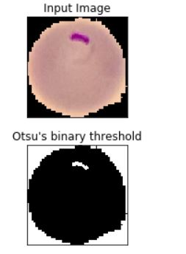

**EXPERIMENT:8(B)**

**AIM:** : Verifying the performance of a image processing by using water shed database with python code

**PROGRAM:**

# SEGMENTATION

import numpy as np

import cv2

from matplotlib import pyplot as plt

img = cv2.imread(r'C33P1thinF_IMG_20150619_114756a_cell_181.png')

b,g,r = cv2.split(img)

rgb_img = cv2.merge([r,g,b])

gray = cv2.cvtColor(img,cv2.COLOR_BGR2GRAY)

ret, thresh = cv2.threshold(gray,0,255,cv2.THRESH_BINARY_INV+cv2.THRESH_OTSU)

plt.subplot(211),plt.imshow(closing, 'gray')

plt.title("morphologyEx:Closing:2x2"), plt.xticks([]), plt.yticks([])

plt.subplot(212),plt.imshow(sure_bg, 'gray')

plt.imsave(r'dilation.png',sure_bg)

plt.title("Dilation"), plt.xticks([]), plt.yticks([])

plt.tight_layout()

plt.show()

**OUTPUT:**

**:** 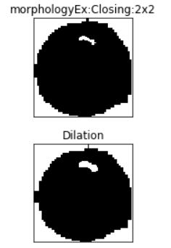

**EXPERIMENT:9 (a) TANH**

**AIM:** Neural network analysis using TANH activation

**OUTPUT:**

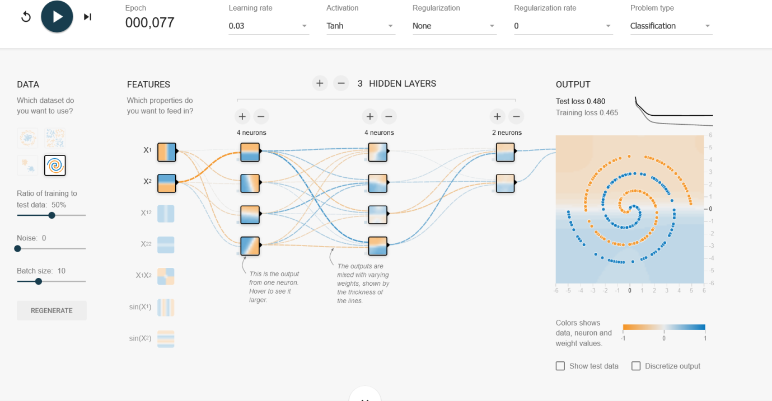

**EXPERIMENT:9(B) SIGMIOD**

**AIM:** Neural network analysis using SIGMOID activation

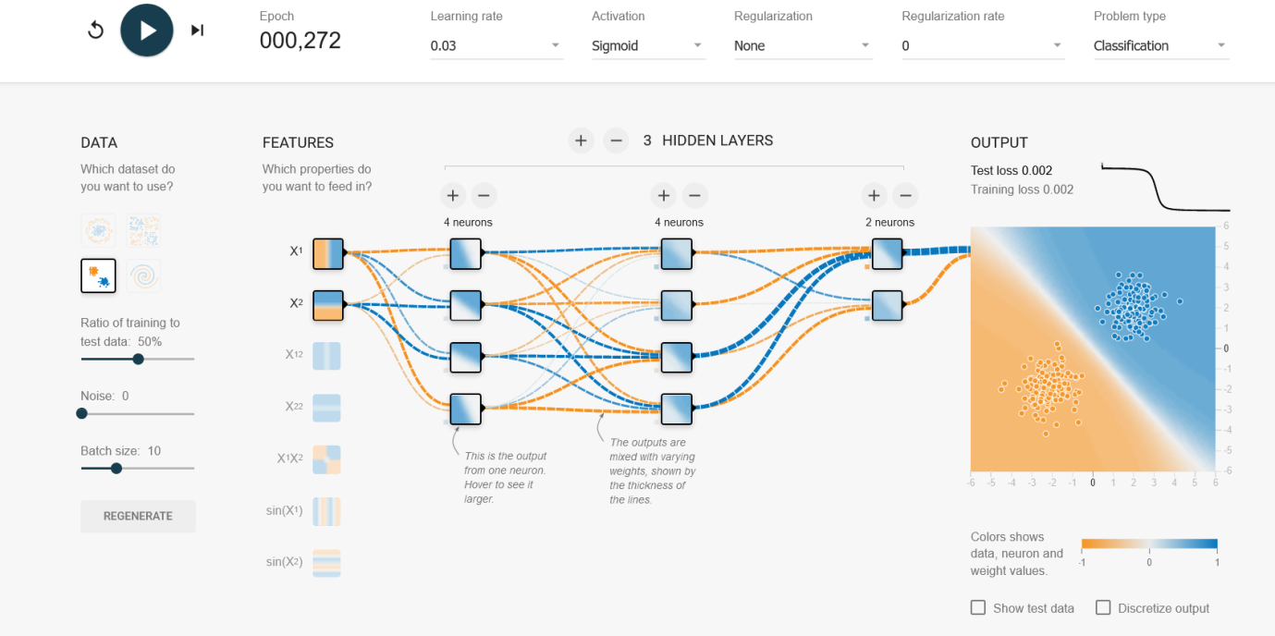

**EXPERIMENT:9(C) LINEAR**

**AIM:** Neural network analysis using LINEAR activation

**OUTPUT:** 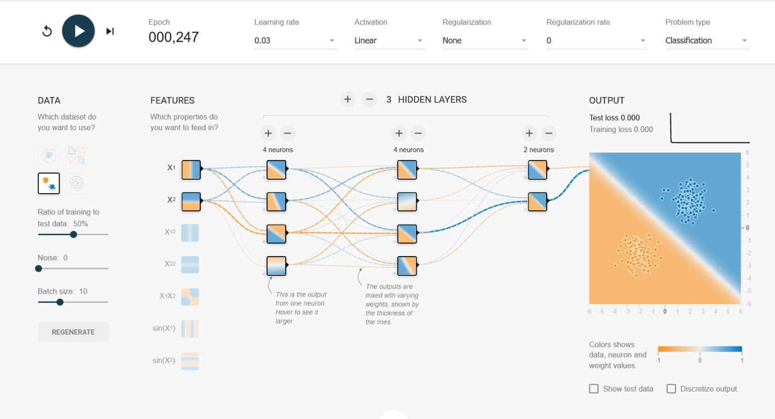

**EXPERIMENT:9(D)RELU**

**AIM:** Neural network analysis using ReLU activation

**OUTPUT:**

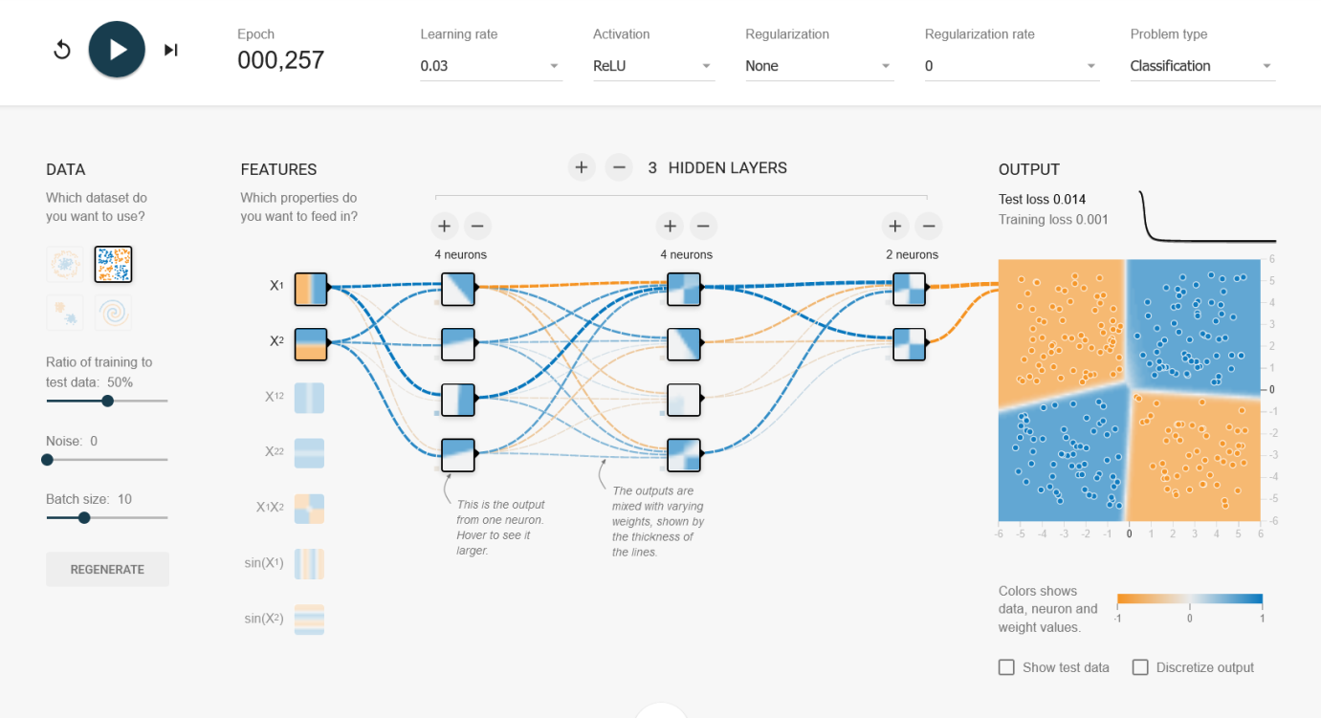

**EXPERIMENT:10**

**AIM:** To demonstrate linear separability using python code

**PROGRAM:**

import numpy as np

import matplotlib.pyplot as plt

def estimate_coef(x, y):

    # number of observations/points

    n = np.size(x)

    # mean of x and y vector

    m_x = np.mean(x)

    m_y = np.mean(y)

    # calculating cross-deviation and deviation about x

    SS_xy = np.sum(y*x) - n*m_y*m_x

    SS_xx = np.sum(x*x) - n*m_x*m_x

    # calculating regression coefficients

    b_1 = SS_xy / SS_xx

    b_0 = m_y - b_1*m_x

    return (b_0, b_1)

def plot_regression_line(x, y, b):

    # plotting the actual points as scatter plot

    plt.scatter(x, y, color = "r",

               marker = "o", s = 30)

    # predicted response vector

    y_pred = b[0] + b[1]*x

    # plotting the regression line

    plt.plot(x, y_pred, color = "b")

    # putting labels

    plt.xlabel('x')

    plt.ylabel('y')

    # function to show plot

    plt.show()

def main():

    # observations / data

    x = np.array([0, 1, 2, 3, 4, 5, 6, 7, 8, 9])

    y = np.array([1, 3, 2, 5, 7, 8, 8, 9, 10, 12])

    # estimating coefficients

    b = estimate_coef(x, y)

    print("Estimated coefficients:\nb_0 = {}  \

          \nb_1 = {}".format(b[0], b[1]))

    # plotting regression line

    plot_regression_line(x, y, b)

if __name__ == "__main__":

    main()

**OUTPUT:**

